**News From Mrs. Zerlaut’s Room**

[**azerlaut@grantps.net**](mailto:azerlaut@grantps.net)

**231-834-7382 X159**

**http://azerlaut.weebly.com**

**March 24/31,2016**

**Ask me about…**

* Vocabulary: 2 dimensional shapes, compare.
* writing workshop: the informational books I’m finishing.
* reading workshop: retelling.
* my 7th grade reading buddy.
* math: playing the *Attribute Train Game.*
* making polygons.
* idioms: “in a pickle”.
* skypeing with an author.
* a storytelling by Mrs. Jensen.
* science: how much precipitation I’ve gathered.
* gym: Mr. Bomay taught me about resolving conflicts.
* mystery readers.
* The Grand Rapids Symphony

Word Wall Words

* very
* which
* wosh
* wish
* their

**Things to remember:**

Mar 31:

End of 3rd MP

April 1-8:

Spring Break

April 18:

Report cards go home

April 29:

Half day

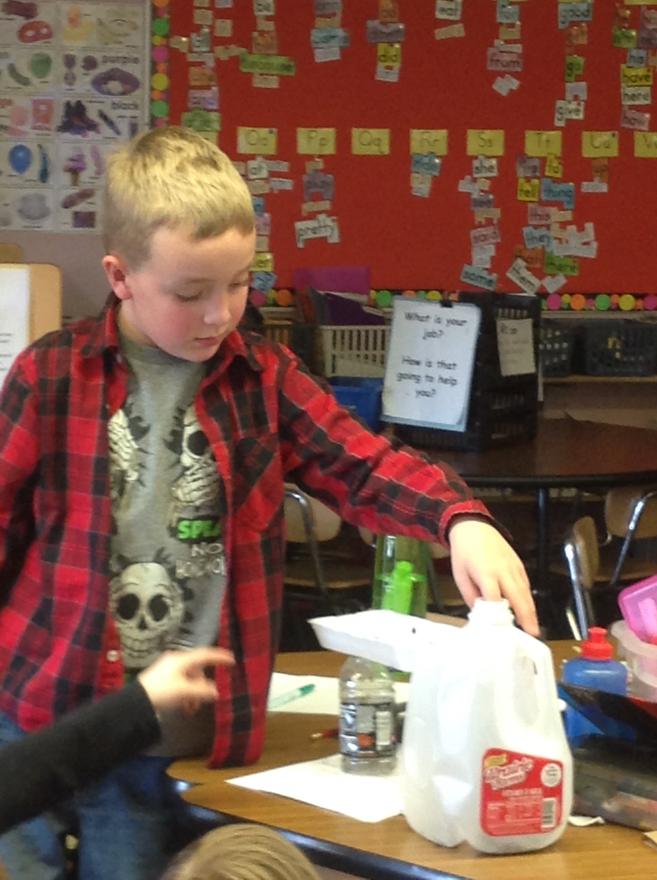

**Family Tip**: **:** Here’s a quick and easy game to improve vocabulary. You could play *“Opposites”* in the car or while waiting for an appointment. You say “sunny”; your child has to say the opposite “cloudy”. Try to make it more challenging: “attack/defend”.

**3rd marking period IXL skills:** B14-B20, B22, B24-B29, D13-D16, F3, F9, K5-K9, K12, S1, S2, S3, S5,S7, S9

**Specials Schedule:**

Monday: gym

Tuesday: library

Wednesday: music, comp.

Thursday: gym

Friday: gym, comp.